Windows10

Hyper-V

Ubuntu 16.04 (recommended)

# Hyper-V安装Ubuntu16.04

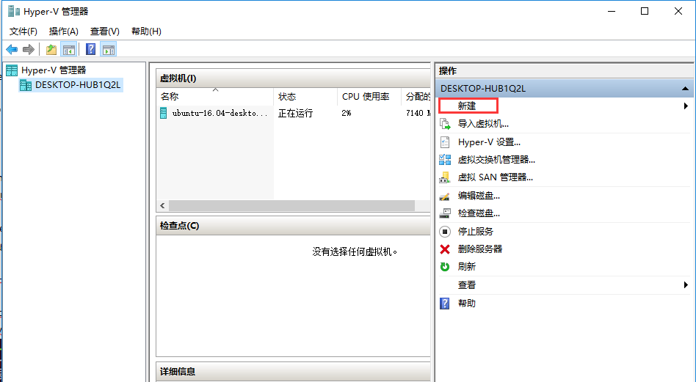

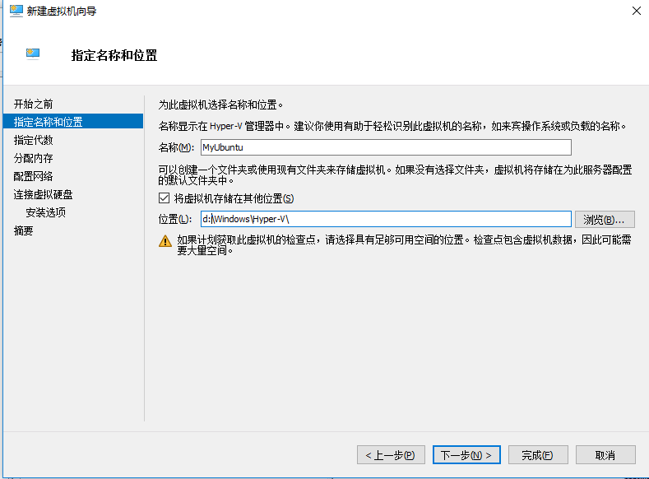





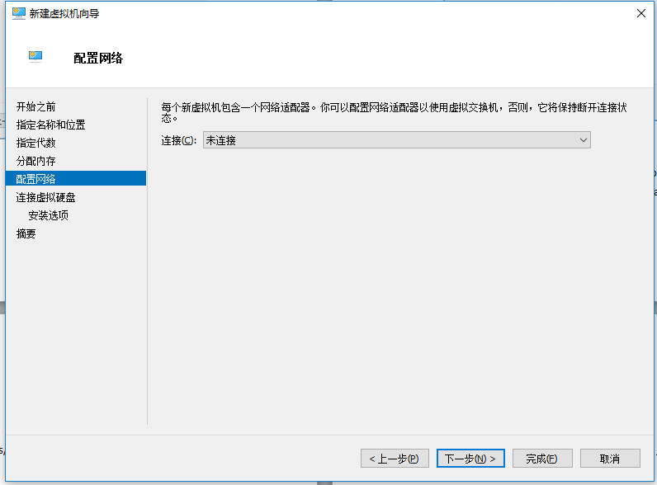

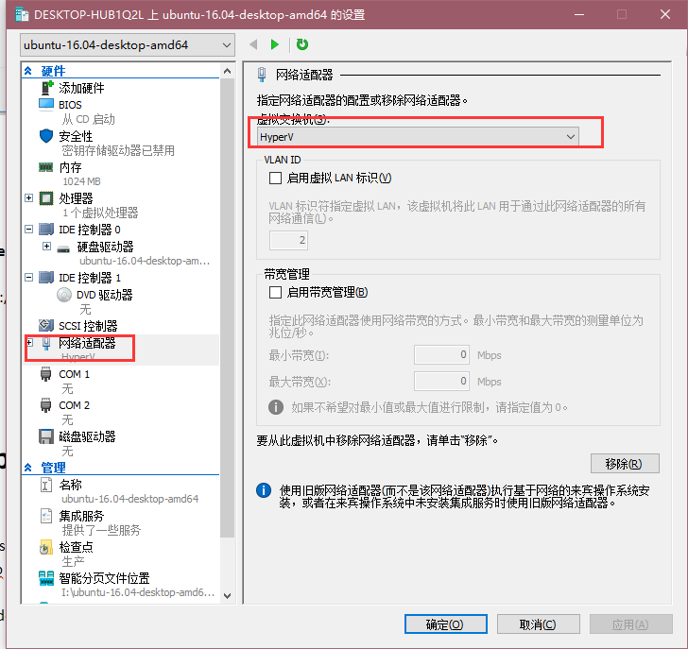

**Hyper-V中虚拟机无法上网的解决方法**

http://www.cnblogs.com/chenxizhang/p/3188005.html

# Ubuntu16.04 安装gitlab

1. Install and configure the necessary dependencies

sudo apt-get install curl openssh-server ca-certificates postfix

2. Add the GitLab package server and install the package

curl -sS https://packages.gitlab.com/install/repositories/gitlab/gitlab-ce/script.deb.sh | sudo bash

sudo apt-get install gitlab-ce

此步error

E:无法获得锁 /var/lib/dpkg/lock-open(11:资源暂时不可用)

E:无法锁定管理目录 (/var/lib/dpkg),是否有其他进程正占用它?



解决方法

命令

ps aux

找出包含apt-get的进程的PID

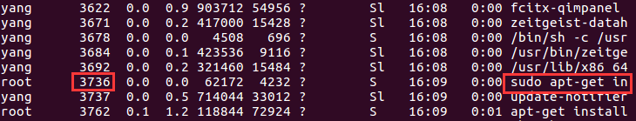

sudo kill 3736

再执行一遍

sudo apt-get install gitlab-ce

此步error

E:dpkg 被中断,您 必须手工运行'sudo dpkg --configure -a'

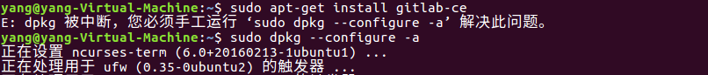

执行sudo dpkg --configure -a

再执行一遍

sudo apt-get install gitlab-ce

等待下载 gitlab-ce ，一共318M左右，看网络状态，我下载了2个小时左右，科学上网速度可能快一点儿。



3. Configure and start GitLab

sudo gitlab-ctl reconfigure

4. Browse to the hostname and login

sudo ifconfig -a 查看IP

http://ip就是gitlab的页面地址

默认用户名是root,密码,进入页面时直接设置即可

# Gitlab配置CI

1：<http://192.168.2.122/cms/wl>

Project

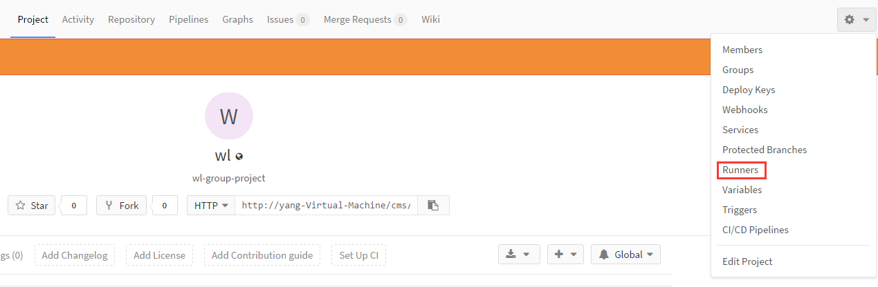

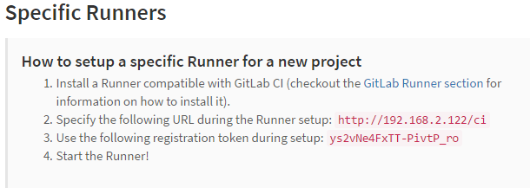

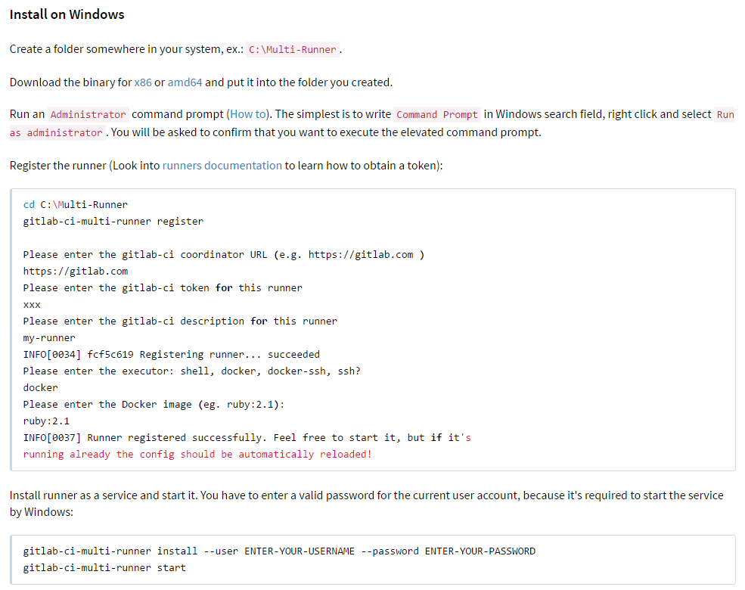

### Install on Windows

新建一个文件夹。比如: E:\Multi-Runner.

根据自身系统下载32位或64位的exe文件，并将安放到刚才建立的文件夹中。

<https://gitlab-ci-multi-runner-downloads.s3.amazonaws.com/latest/binaries/gitlab-ci-multi-runner-windows-386.exe>

<https://gitlab-ci-multi-runner-downloads.s3.amazonaws.com/latest/binaries/gitlab-ci-multi-runner-windows-amd64.exe>

以管理员管理打开CMD。

Register the runner

cd E:\Multi-Runner

E:\Multi-Runner>gitlab-ci-multi-runner-windows-amd64.exe register

Please enter the gitlab-ci coordinator URL (e.g. https://gitlab.com/):

http://192.168.2.122/ci

Please enter the gitlab-ci token for this runner:

ys2vNe4FxTT-PivtP_ro

Please enter the gitlab-ci description for this runner:

[DESKTOP-HUB1Q2L]: test cirunner

Please enter the gitlab-ci tags for this runner (comma separated):

CIRunner

Registering runner... succeeded [0;m runner[0;m=ys2vNe4F

Please enter the executor: docker-ssh, shell, ssh, virtualbox, docker-ssh+machine, kubernetes, docker, docker+machine, parallels:

shell

Runner registered successfully. Feel free to start it, but if it's running already the config should be automatically reloaded![0;m

安装成服务

E:\Multi-Runner>gitlab-ci-multi-runner-windows-amd64.exe install Yangcz cms2016...

E:\Multi-Runner>gitlab-ci-multi-runner-windows-amd64.exe start

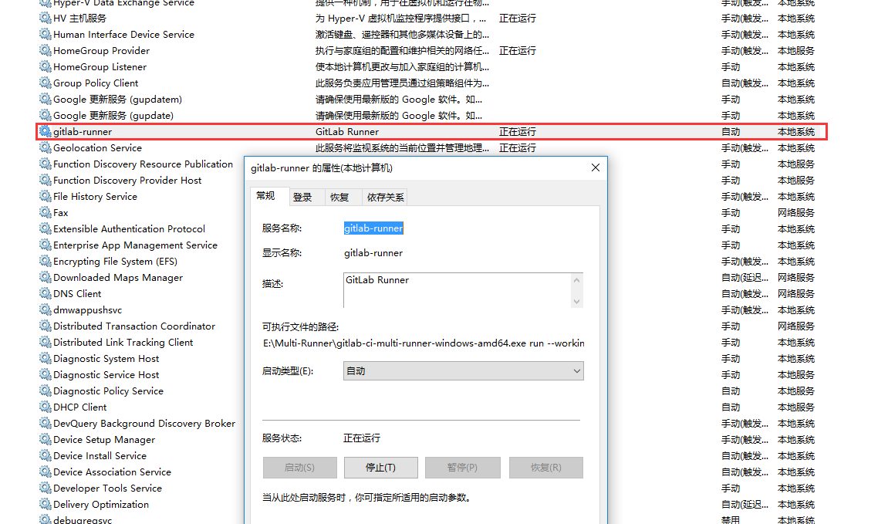

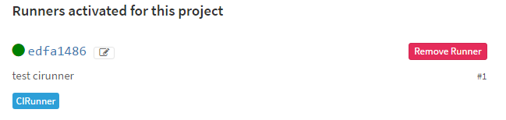

**配置并启动 Gitlab**

此时已经可以启动服务了：

sudo gitlab-ctl reconfigure

进行一长串复杂的启动流程之后， gitlab 就已经可以通过 localhost 进行访问了。

**Gitlab 配置**

**修改域名**

默认的配置文件保存在 /etc/gitlab/gitlab.rb ，执行：

sudo vim /etc/gitlab/gitlab.rb

打开文件，并修改：

external_url 'http://your.domain'

再次执行

sudo gitlab-ctl reconfigure

即可。

有一定概率出现 502 错误，刷新浏览器或者再次更新配置即可。

当有代码push到master时会触发CI。例如：

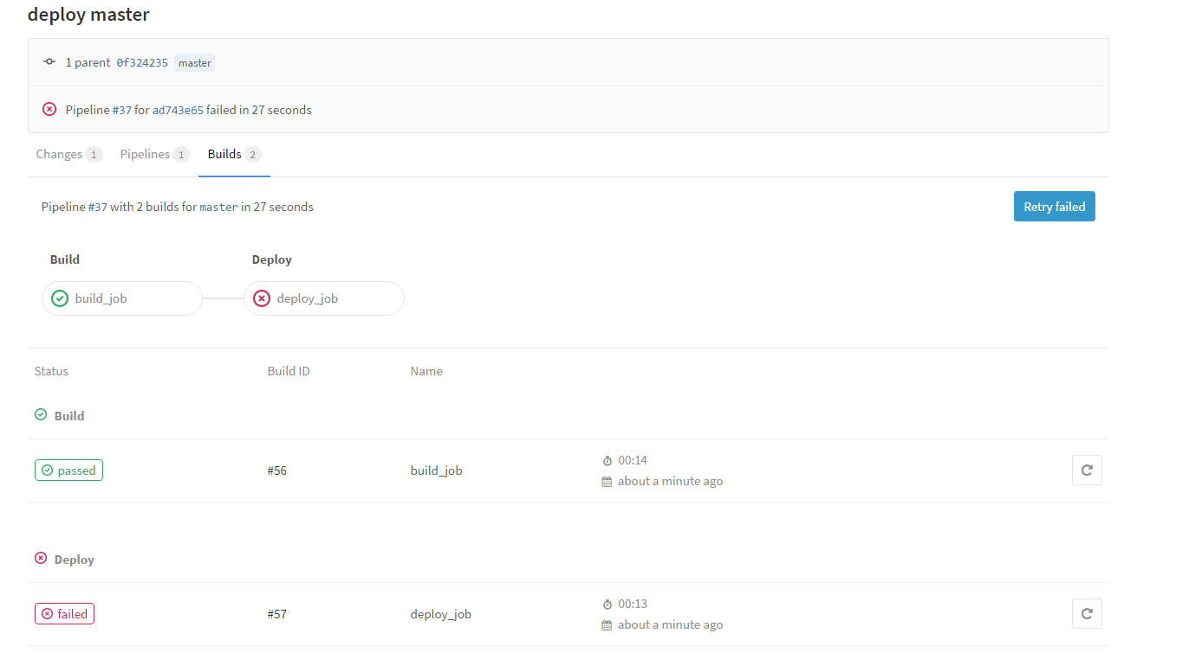

Build成功

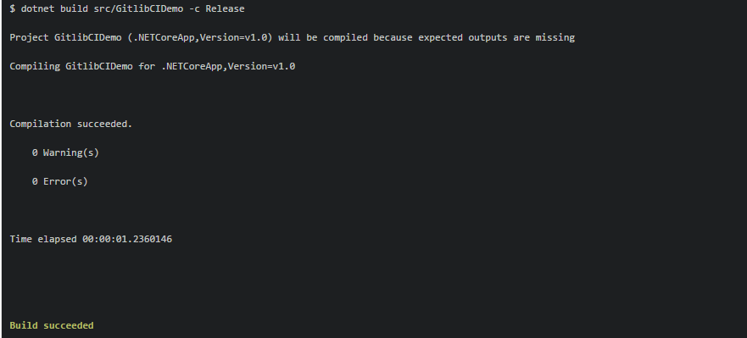

Deploy失败

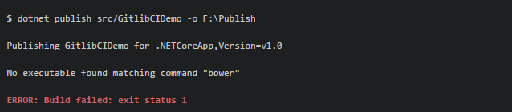

$ dotnet publish src/GitlibCIDemo -o F:\Publish   
Publishing GitlibCIDemo for .NETCoreApp,Version=v1.0   
No executable found matching command "bower"   
**ERROR: Build failed: exit status 1**

安装bower

注意：需要以管理员方式打开CMD

参考文档

<http://www.jianshu.com/p/6cda6ca6cce1>

安装之后仍然报同样的错误

将src/project.json中的scripts节点下面的内容删除或注释掉



提交到git它会自动触发ci

Build和deploy 都成功了。

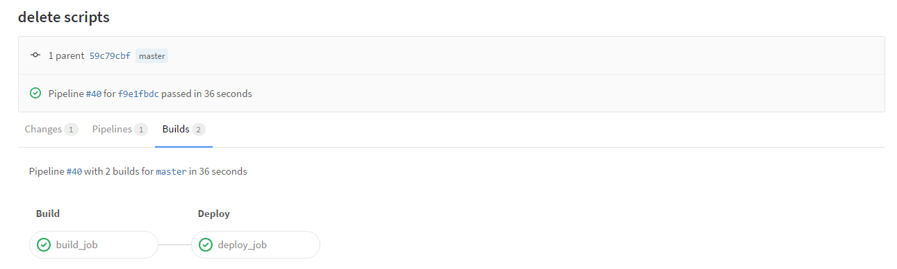

看我们的F盘中已经有发布后的文件了。



如果IIS中的站点指向这个路径，那么就可以直接在浏览器中访问此站点了。

但此时报错

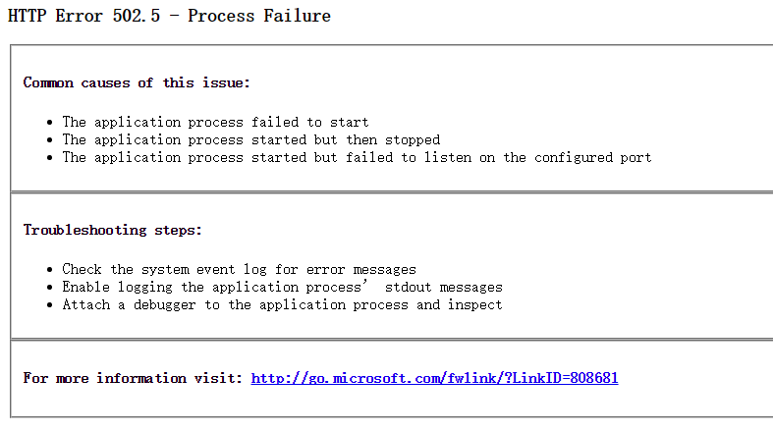

### HTTP Error 502.5 - Process Failure

#### Common causes of this issue:

* The application process failed to start
* The application process started but then stopped
* The application process started but failed to listen on the configured port

#### Troubleshooting steps:

* Check the system event log for error messages
* Enable logging the application process’ stdout messages
* Attach a debugger to the application process and inspect

#### For more information visit: [http://go.microsoft.com/fwlink/?LinkID=808681](http://go.microsoft.com/fwlink/?linkid=808681)

解决办法：

修改Web.config

<!--<aspNetCore processPath="%LAUNCHER_PATH%" arguments="%LAUNCHER_ARGS%" stdoutLogEnabled="true" stdoutLogFile=".\logs\stdout" forwardWindowsAuthToken="false"/>-->

<aspNetCore processPath="C:\Program Files\dotnet\dotnet.exe" arguments=".\GitlibCIDemo.dll" stdoutLogEnabled="true" stdoutLogFile=".\logs\stdout" forwardWindowsAuthToken="false"/>

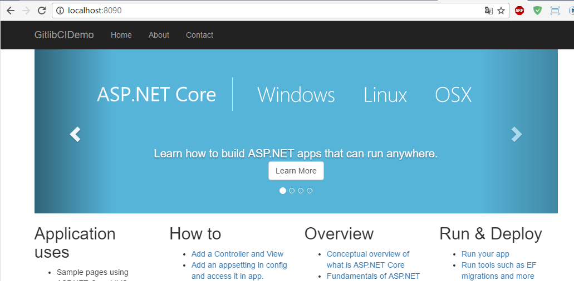

502错误 参见

<https://github.com/aspnet/Hosting/issues/844>

<http://www.cnphp6.com/detail/21746>

参考资料：

http://www.cnblogs.com/chenxizhang/p/3188005.html

https://www.zybuluo.com/bornkiller/note/314902

Ubuntu 16.04安装.Net Core 1.1

<https://www.microsoft.com/net/core#linuxubuntu>

Ubuntu 搭建 Shadowsocks

<http://www.jianshu.com/p/b5c4fbadbfae>

将shadowsocks.json将到home文件夹内

将shadowsocks.json移动到/etc文件夹内.当前用户没有etc文件夹的操作权限

sudo mv shadowsocks.json /etc

[Ubuntu下添加开机启动脚本](https://wangheng.org/ubuntu-to-add-boot-script.html)

ssserver -c /etc/shadowsocks.json -d start

//<https://wangheng.org/ubuntu-to-add-boot-script.html>

Exception：libsodium not foud

安装它， Shadowsocks.使用chahca来加密，需要使用libsodium

http://blog.csdn.net/qq_15437667/article/details/50752399?locationNum=1&fps=1

./configure命令错误

<http://www.cnblogs.com/niocai/archive/2011/07/14/2106088.html>

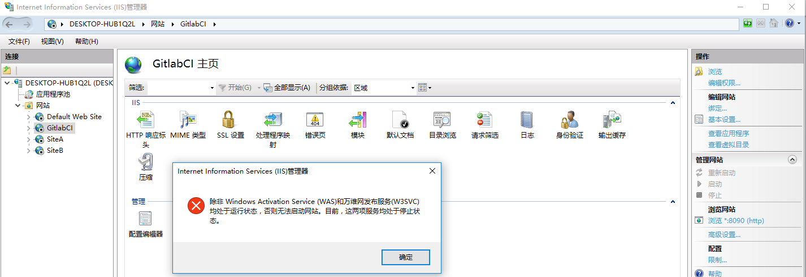

解决办法：

在WINDOWS服务管理里 启动 World Wide Web Publishing Service 即可！

